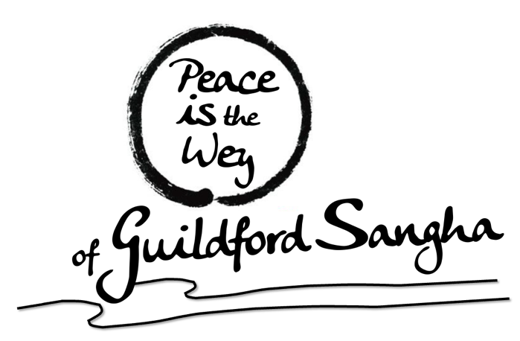
“Nature Awareness”
Monthly in Person Meditation gathering Session by
“Peace is the Wey of Guildford Sangha”
Sunday 6th August 2023
Location: Lower Bourne – Farnham – exact address TBC via What’sApp Group

Bell Master: Lawrence
Morning Programme:
- 9:30am - 10:30am: Nature Awareness Sangha, Farnham Heath walk / float in when you like and chat / sit with a book / cloud watching
- 10:30am - 11am: Tea/chat
- 11am - 11:30pm: Guided meditation - Facilitated by Michele
- 11:30am - 12pm: Touching the Earth - Facilitated by Sabry
- 12:30pm: Shared picnic, vegan lunch (everyone brings some simple vegan dish to share)

